SUMMARY 2
Part Section 2.2
GPU supports named barriers through instructions : 2 instructions – sync and arrive
sync – It causes threads in warps arriving at the barrier to block until barrier completes
arrive – It allows a warp to register arrival at a barrier and execute without blocking.
Producer- Consumer synchronization can bemaintained by the former instructions.
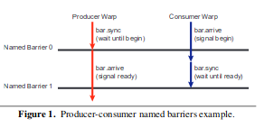

Producer consumer synchronization is maintained through sync and arrive instructions. Producer warp initially blocks on named barrier 0 using sync , at some point consumer warp signals by using an arrive instruction on named barrier 0.Since consumer warp issues non-blocking arrive instruction , it can continue to perform additional work until producer generates data.Then the consumer warp blocks on named barrier 1 waiting for data to be ready.The producer warp signals that data is ready by performing a non blocking arrive on named barrier 1 and continue executing.

Once the named barrier completes, it is reinitialized so that it can be used again. Different generation(each use of a named barrier) can have different number of participants. These also create failures like deadlocks unlike CUDA.

Section 2.3
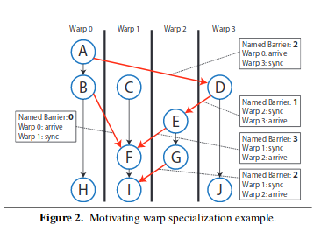

The graph is given for the mapping of static dataflow graph onto warps. They are straight codes and when there is a edge between 2 warps, the warps use the named barrier access the shared memory and maintain synchronization.
First Property: Reuse of named barrier
A happens-before –relationship must be established between any 2 generations which are using the same named barrier but one generation should complete before the other.
From figure we can see that named barrier 2 is reused. Barrier 2 completes before operation D is run .The happens before relationships established by paths D→E→F→I and D→E→G , using named barriers 1 and 3 , ensure that warps in next generation of barrier 2 have a relationship with previous generation of barrier 2, therefore it can be used again.
When All barriers must successfully execute and be properly reused ,It is called well synchronization kernel , but checking for this property in a CUDA code is impractical.
Second property : Synchronization pattern is completely static
Named barriers constrain the synchronization so it is both deterministic and known at compile time. As said before, the threads execute straight line codes having no dynamic branches or loops or else it is impossible to obtain complete solution. Another reason for not using dynamic branches in GPU’s is that it is highly expensive

Intro of Section 3
Here this paper will be discussion only with individual CTAs and not inter-CTA synchronization or software level intra-CTA synchronization(as it is slower than named barriers). Assumption is made that all CTAs execute same program so one CTA is considered for verification.
The verification of atomics are orthogonal problem(independent) to the verification of named barrier usage.
Some variables are used to programs such as :
T - CTAs
P - threads
g – shared memory location
c – command in a thread
B – 16 named barriers
b – specific barrier name, ( id of named barrier)
n – expected no of threads to register at a generation of barrier
command can either read, write or perform a synchronization operation(sync – blocking op and arrive – non blocking op).

